

ROW 8 (50 GPD)

Reversed osmoses unit, 5 phase filtration with pressure pump

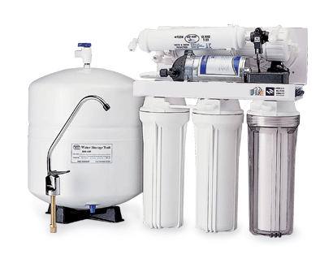
- type wall mount
- water pressure supply 1,5-5 bar
- water quality supply <11°dH
- water supply 1/4”
- water drain 1/4”
- R.O. water 1/4”
- 50 GPD membrane
- 5 phase water filtration
- max. water capacity 180 litre per day R.O.
- voltage 230 Volt / 30W
- membrane pressure pump
- dimensions ( cm ) LxWxH 21x37x45
- weight 18 kg (in use)
- 19 ltr tank capacity.
- complete set

order code for the applied filters
Sediment filter 5 micron: F-10I-5m
Bloc filter: F-10I-AC
G.A.C. carbon filter: F-10I-GAC
Membrane: TW 30-1812-50
Post carbon filter: F-IL-PC

